Climate Crisis
By Aarti: 27 November 2023

Climate change, defined as any long-term change in the patterns of average weather of a specific region or the Earth as a whole, is the result of a number of factors. But this happens more due to human activities. Studies have shown that since the Earth's climate system is considerably large and moves slowly, it has time-lags in its reaction to inputs. Our Earth’s climate is changing faster than ever before according to the recent bulletin released by the United Nations’ weather agency, World Meteorological Organisation.
Reports from various sources, including Intergovernmental Panel on Climate Change (IPCC), highlight that the challenges faced due to global warming are mainly due to cumulative historical and current GHG emissions of the developed countries. Even as India accounts for more than 17 percent of the global population, it has contributed only about 4 percent of the global cumulative CO2 emissions between 1850 and 2019; it has been taking concerted steps to combat climate change.
The National Action Plan for Climate Change (NAPCC) launched in 2008 provides for climate change mitigation and adaptation through its national missions in solar energy, energy efficiency, water, sustainable agriculture, health, Himalayan ecosystem, sustainable habitat, green India, and strategic knowledge for climate change. India is also a signatory to the Paris Agreement (2015) which aims to hold the increase in the global average temperature to well below 2°C above pre-industrial levels and pursue efforts to limit the temperature increase to 1.5°C above pre-industrial levels. At least 149 countries have reportedly updated their pledges under the 2015 Paris climate agreement to curb their GHG emissions by 2030.
Climate change is an expensive problem globally which includes direct and indirect economic losses. If CO2 amounts are reduced so as to stop it increasing after the year 2050, then the global average temperature will increase from 1-1.5°C, which is considered a best-case scenario, else our future generations can be impacted rather adversely in the worst-case. The amount of climate change by the end of the century depends on decisions made today. Many macro level climate solutions require world’s largest economies to effectively deal with emissions cuts.
We can contribute in many ways to minimise the effects of climate change by going greener and cleaner. These can range from better solid waste management, tree plantation, wetland restoration and adopting renewable energy. Studies have shown that consumer-spending fuels the global economy which is the biggest single cause of climate change. Importantly, there is an imperative need to curb one’s disposable habits by buying only what is needed as it can reduce emissions from packaging and transportation.
Thanks to our several start-ups, many of the green products (used in the world’s greenest countries ranked on environmental performance index, that boast of preserving and restoring the natural environment) are now available in India. Such green products, including green laundry detergents, cleaners, reusable shopping bags manufactured using toxic-free ingredients and environmentally-friendly processes are not only sustainable, but designed to minimise its environmental impacts during its whole life-cycle and even after it is of no use. They have reduced or zero carbon/plastic footprint. As they can be recycled, reused, being biodegradable in nature, it reduces waste and maximises resource efficiency.
Organic green products like pulses, grown without the use of toxic chemicals or genetically modified seeds under hygienic conditions, lead-free, vegan cosmetics, cruelty-free lipsticks, nail polishes, eyeshadows – all free of toxins, paraben, alcohol, and sulphates are all gaining popularity. The impact of climate change we are witnessing is just a tip of the iceberg but the writing on the wall is quite clear: much worse lies in store for us ahead unless we quickly act to arrest it. A small step by every individual can help combat climate change.
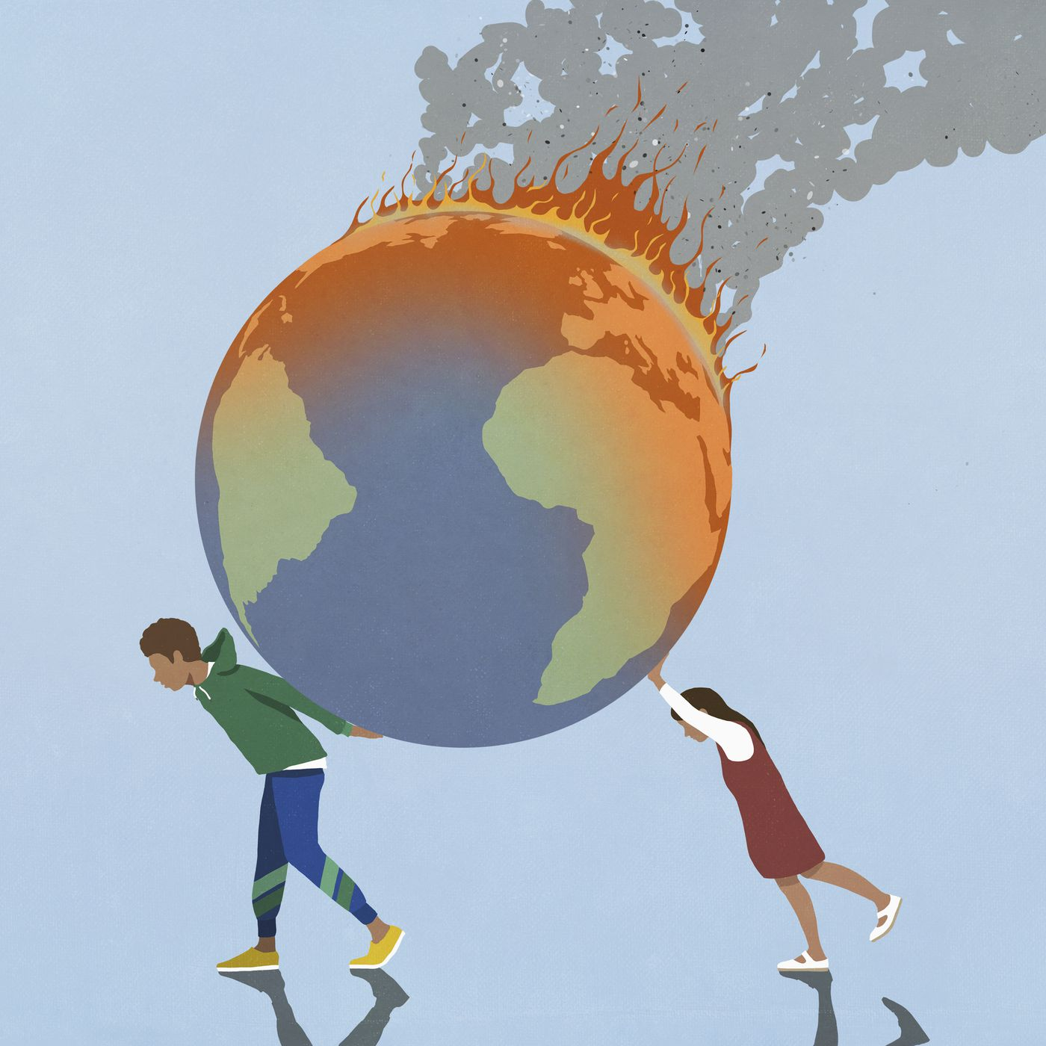

https://www.indiancurrents.org/story-climate-crisis-aarti-383.php

